Steps ahead of the rest!
The Stepper® is like an extra set of hands!

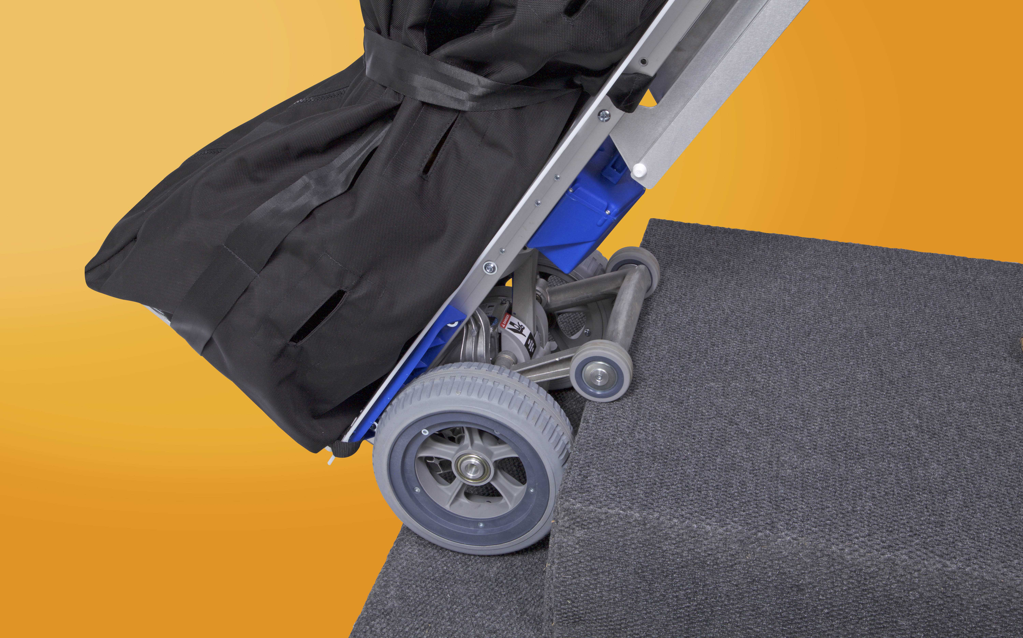

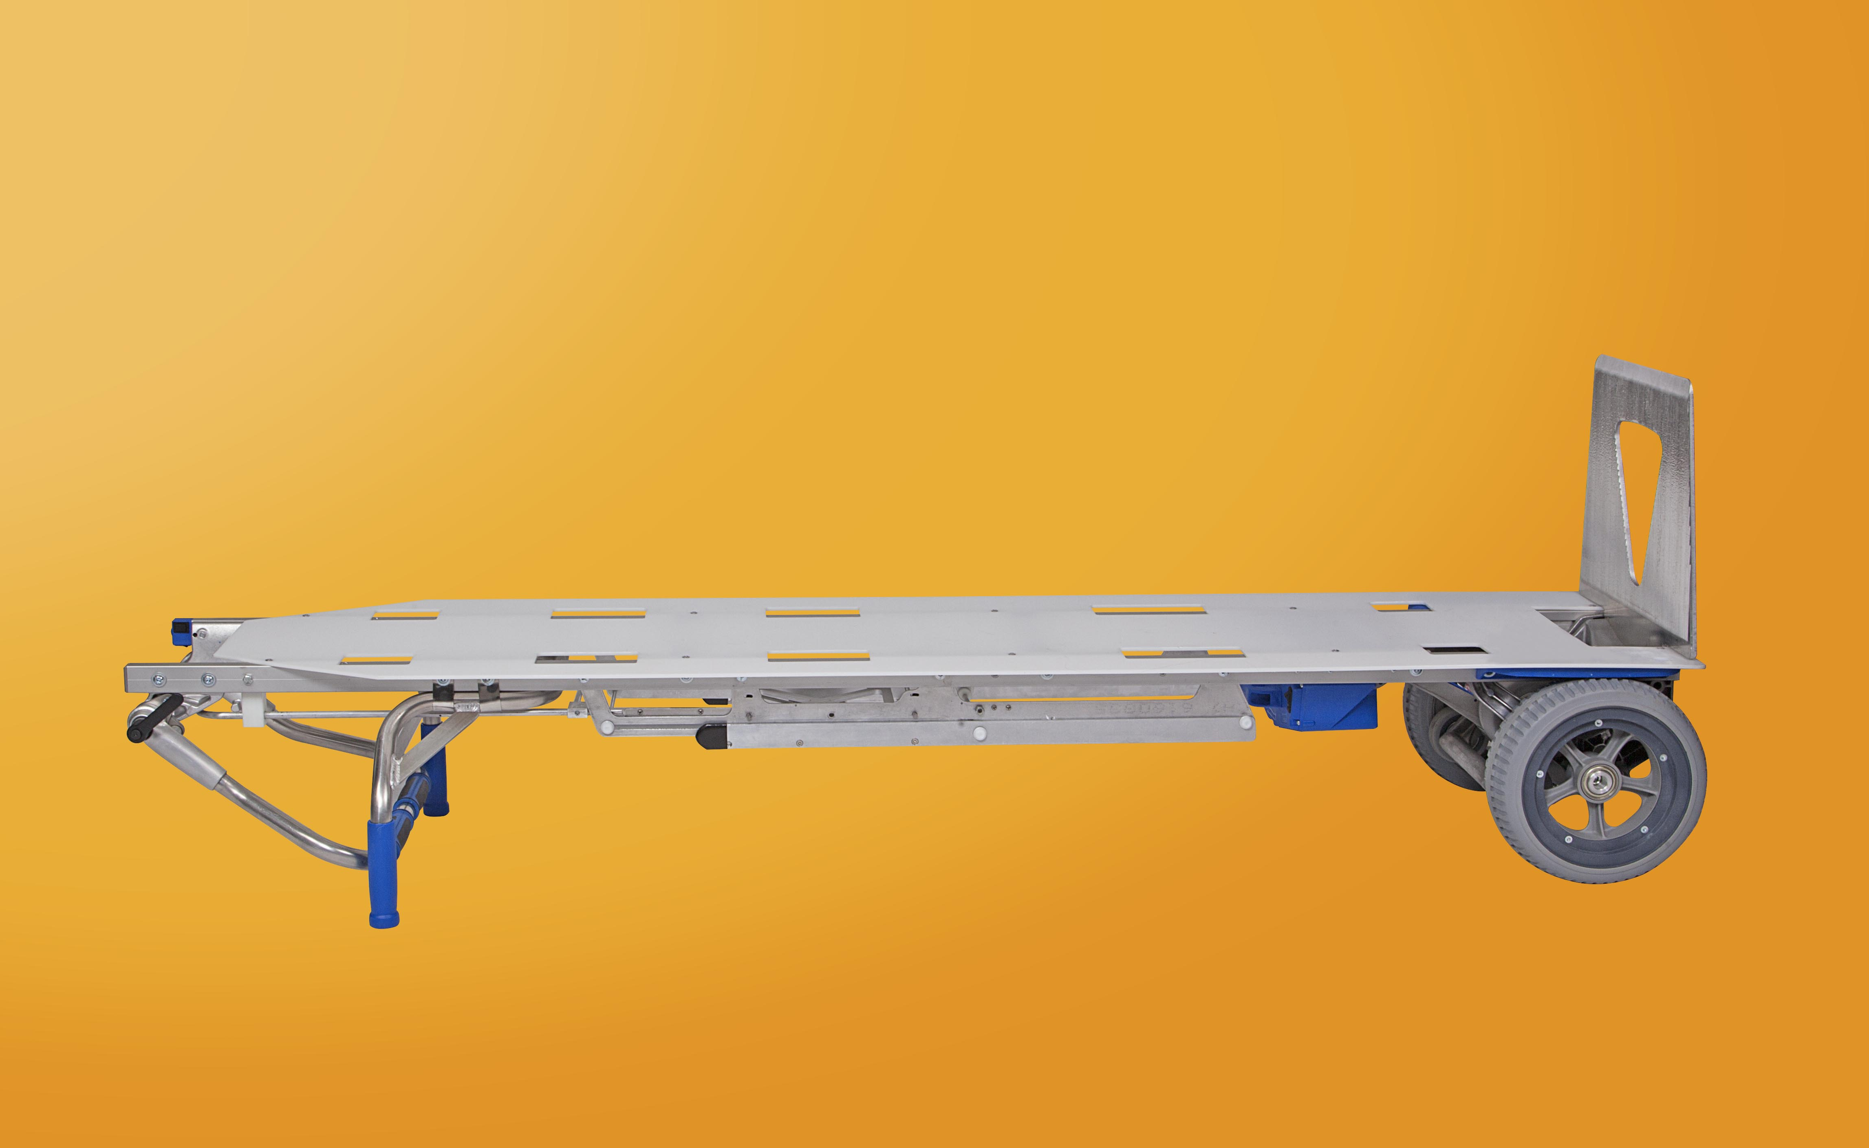

Includes: Body glide board, two sets of straps, one battery, one charger
Optional: Body pouch (designed with side pull handles and back insert holes for inside strap down), car battery charger, extra battery, extra straps

Featuring the QuickStand™: A two-stage prop stand for ease in supporting your load.
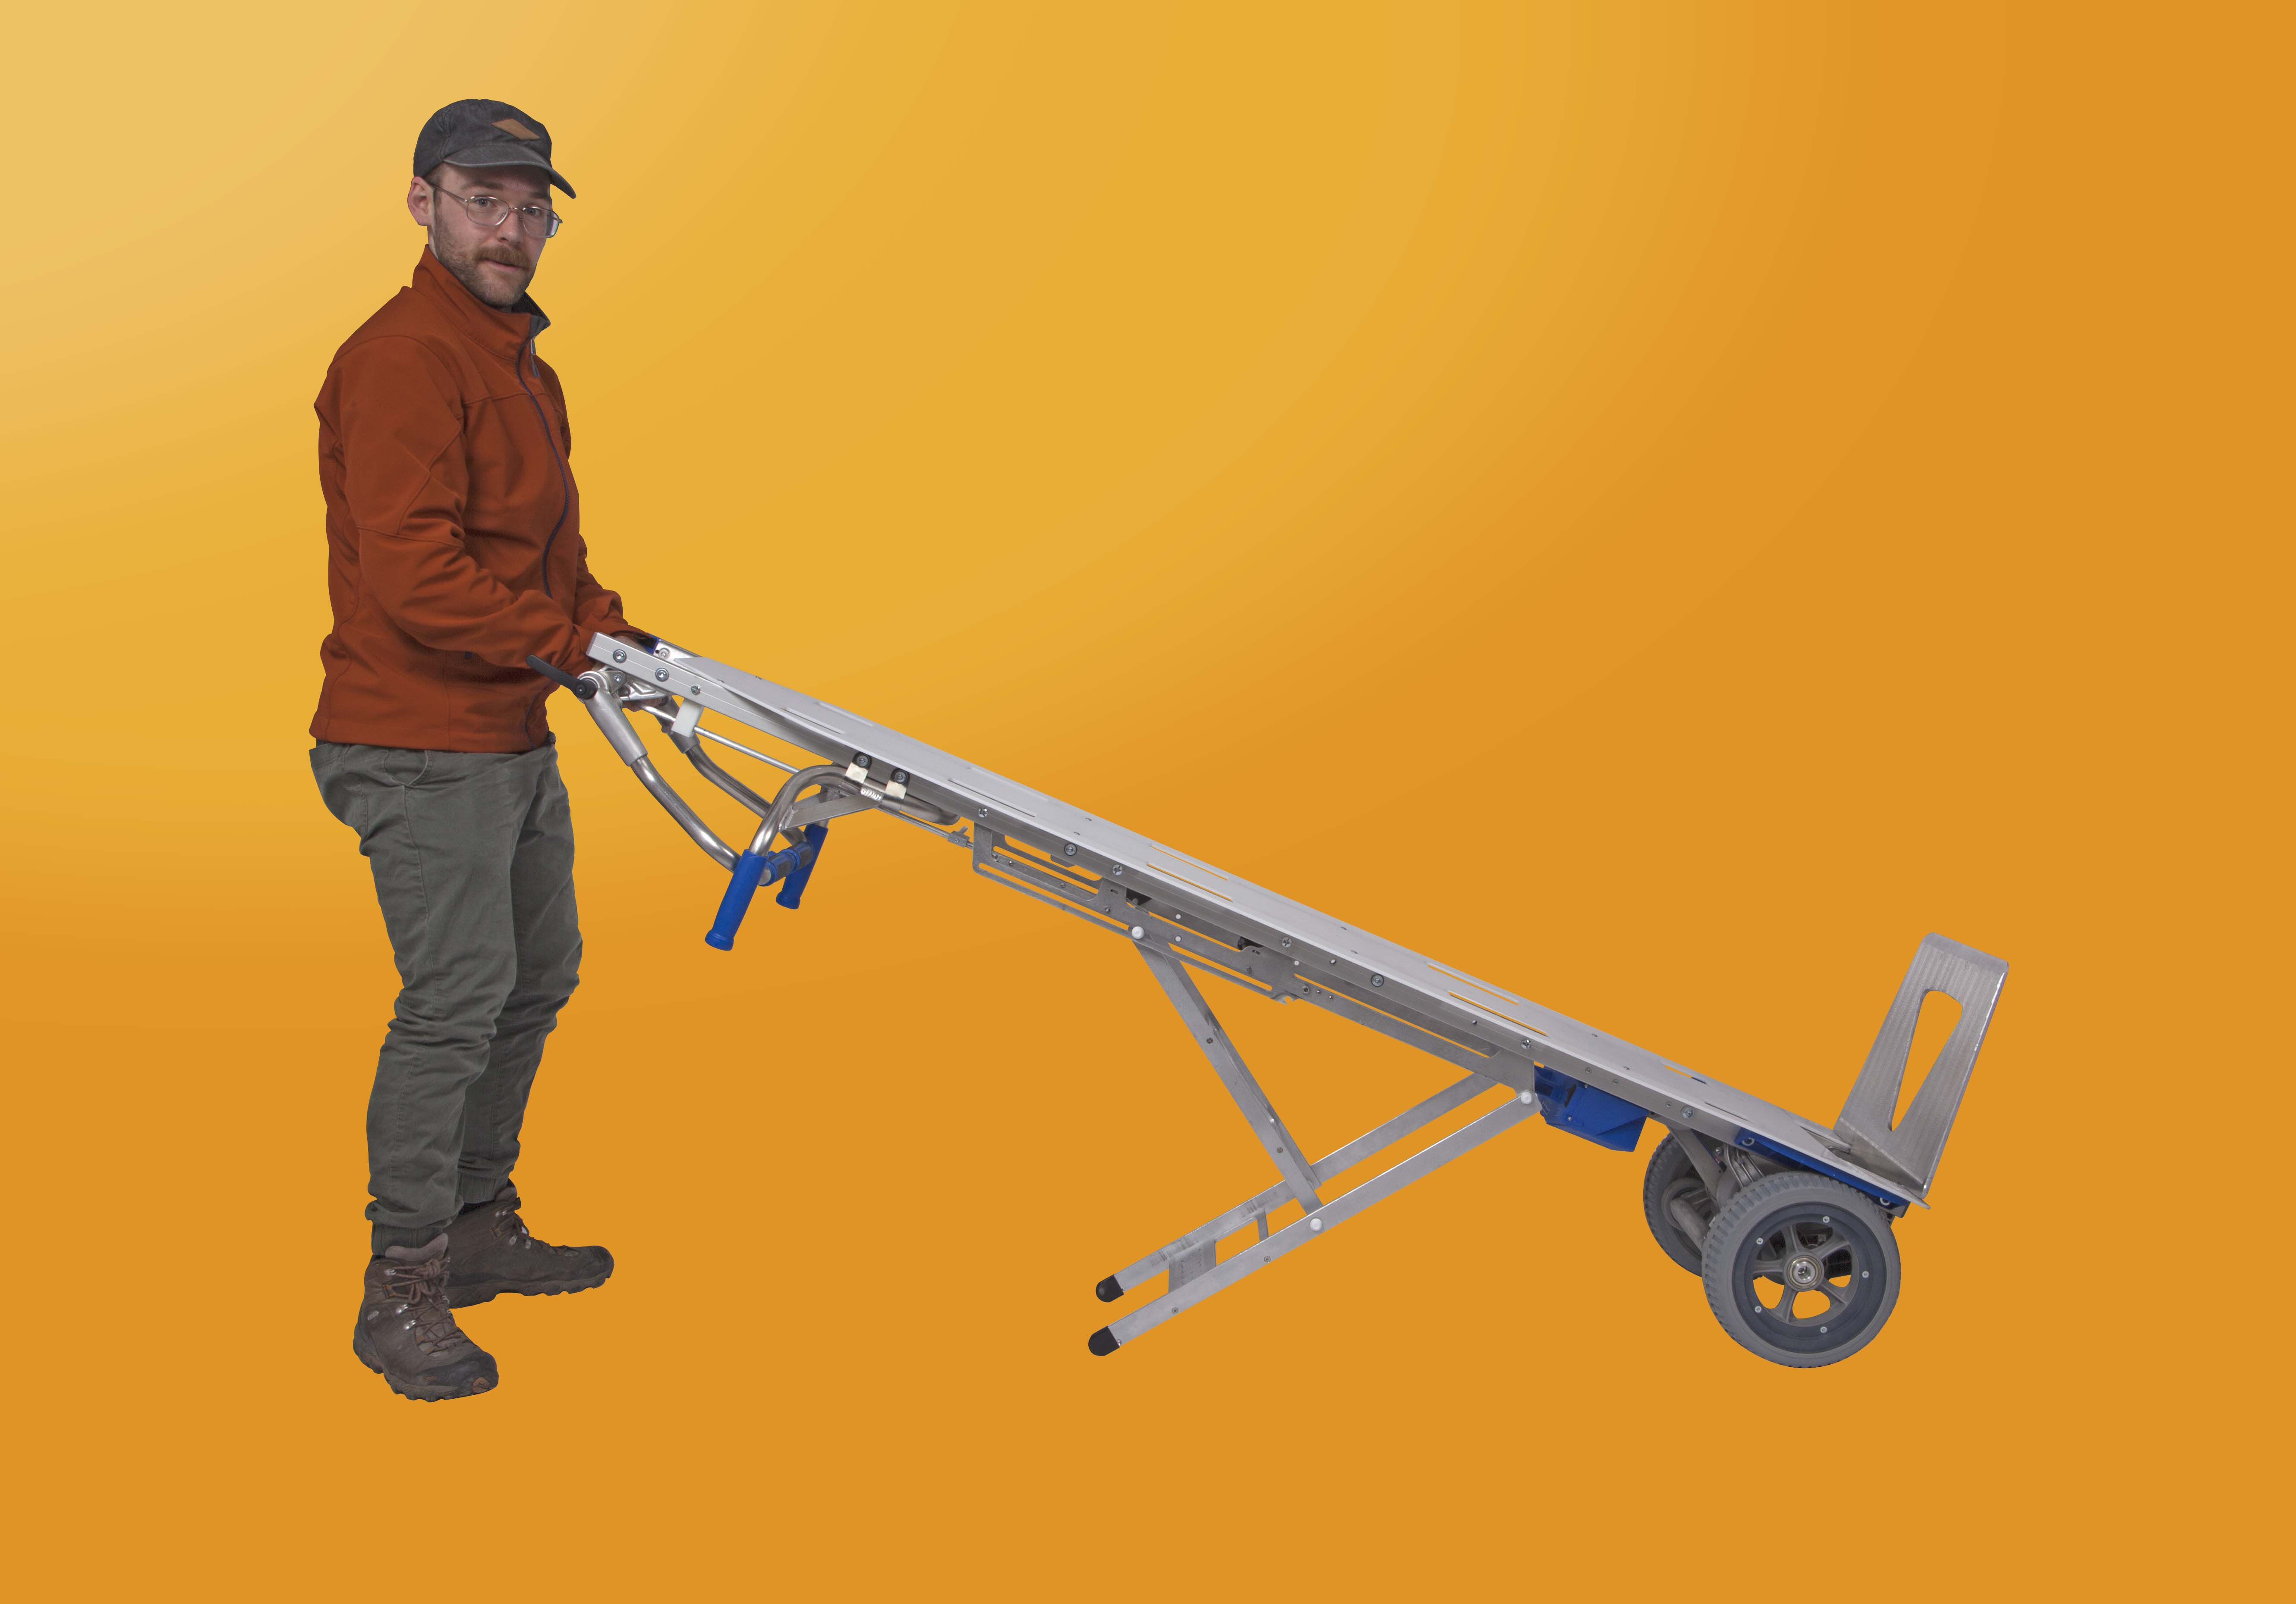
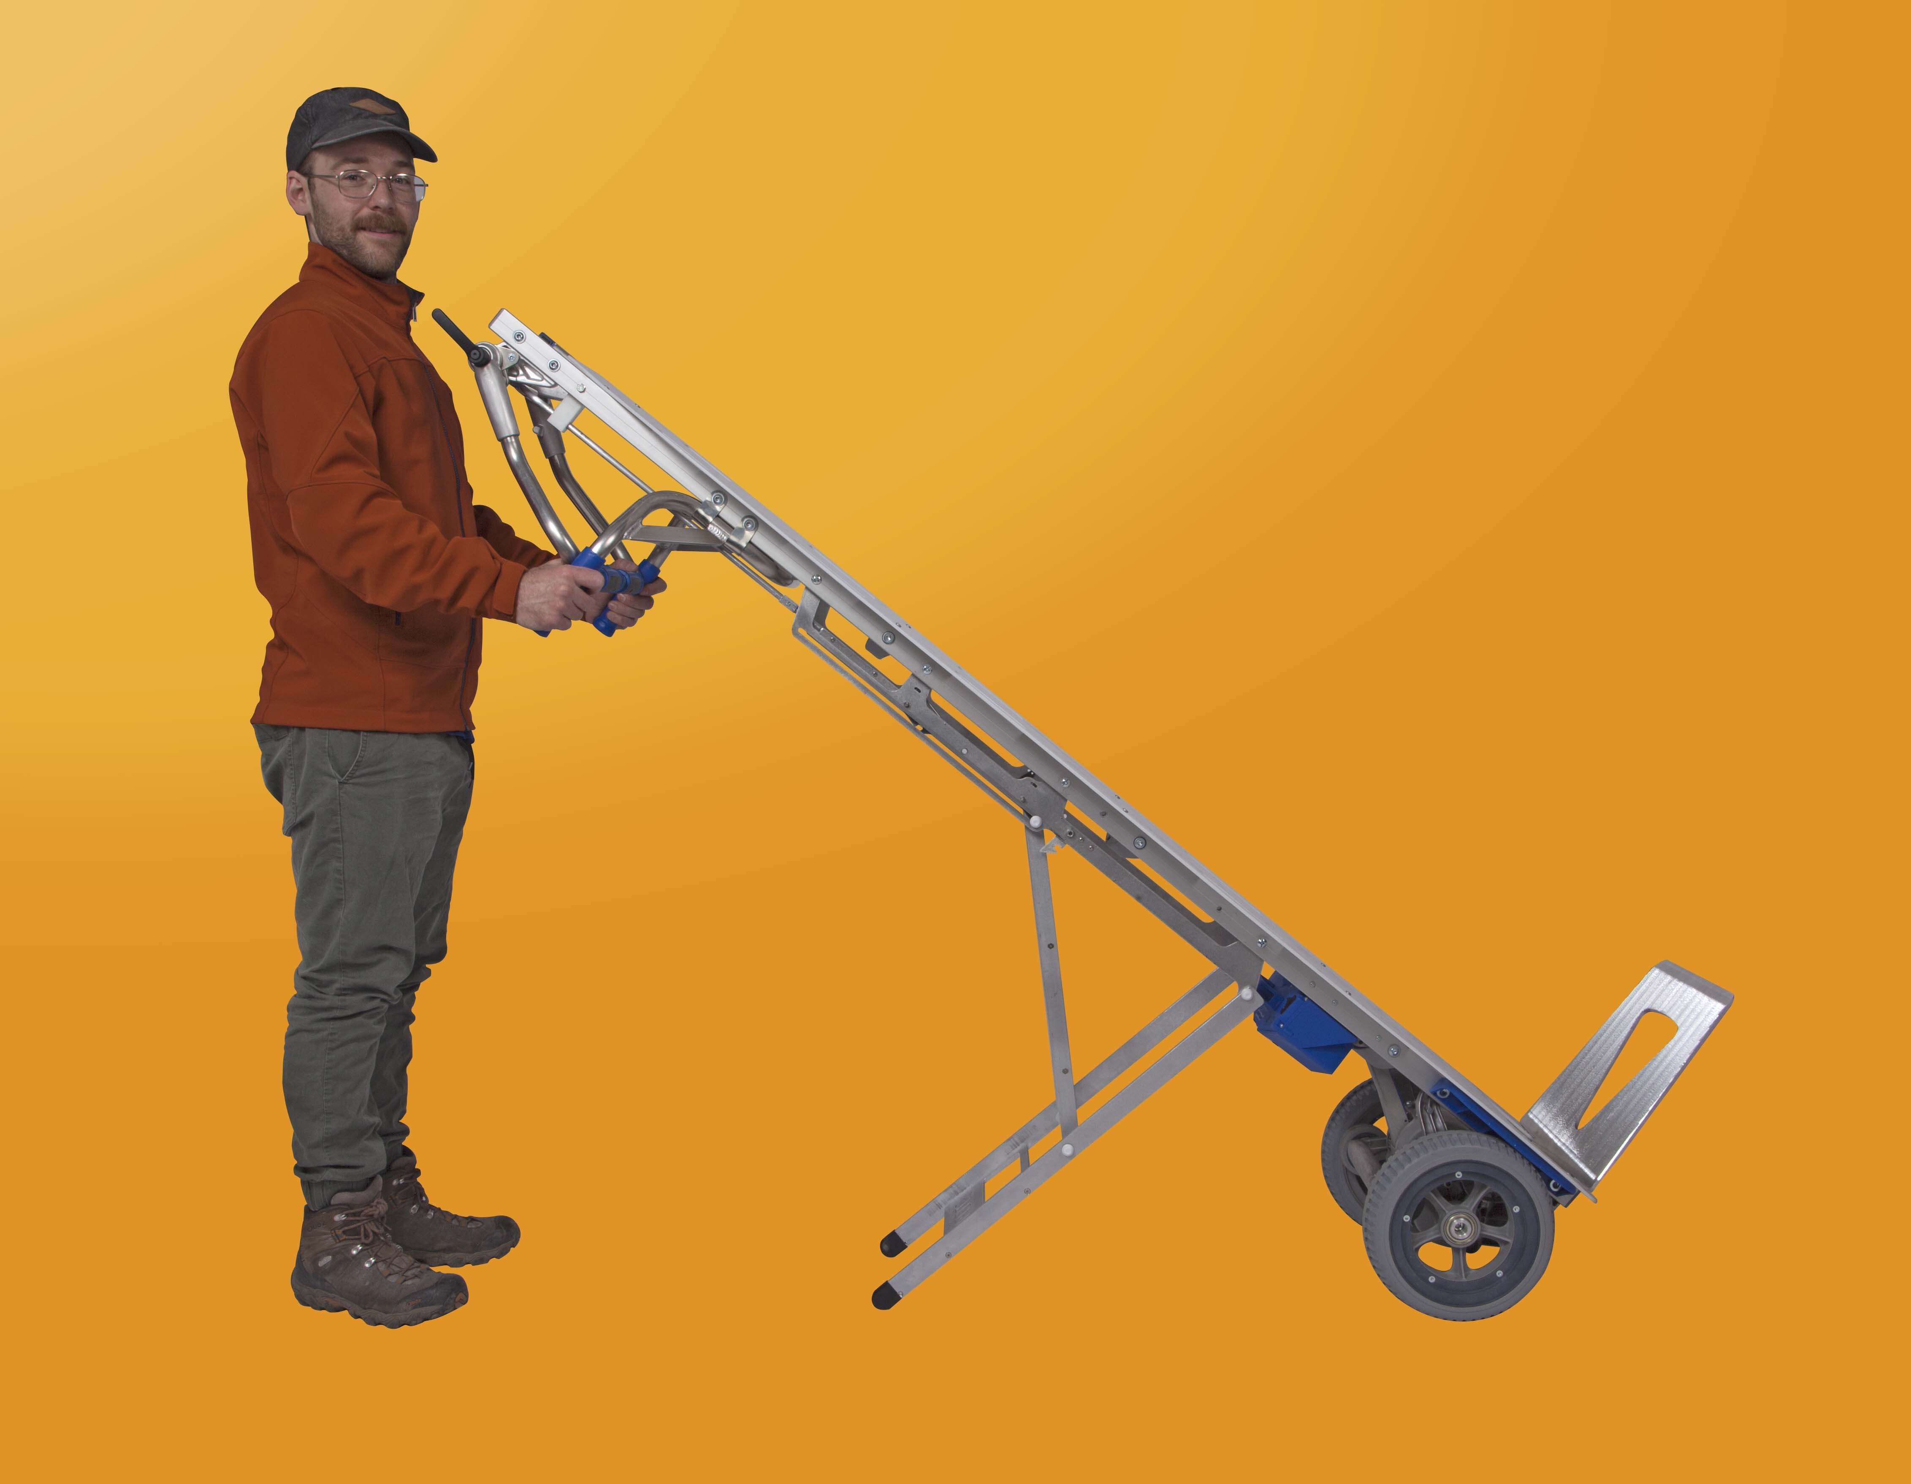
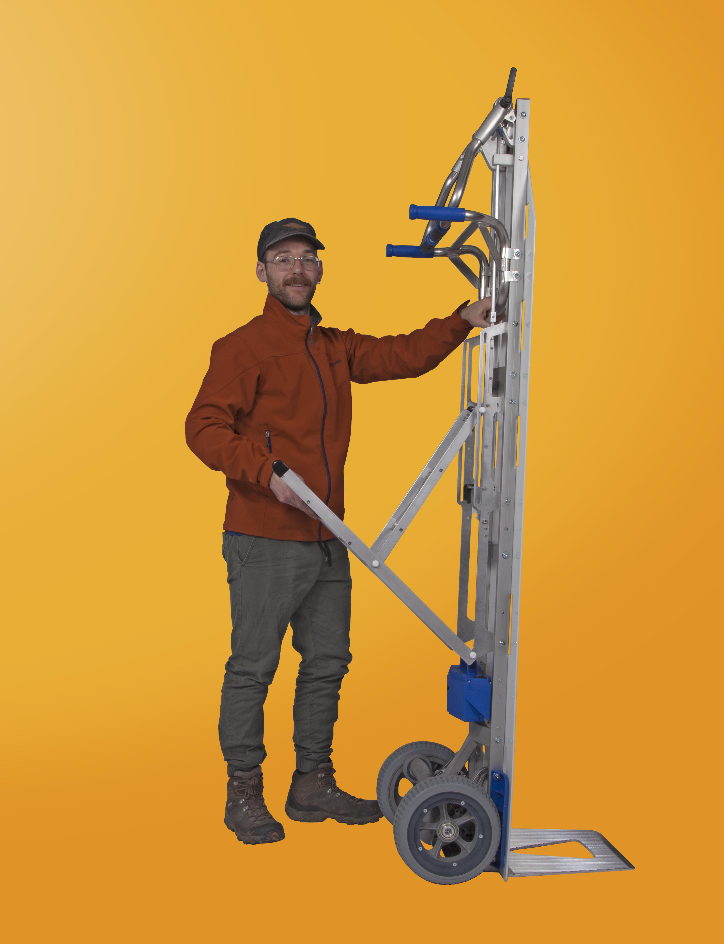
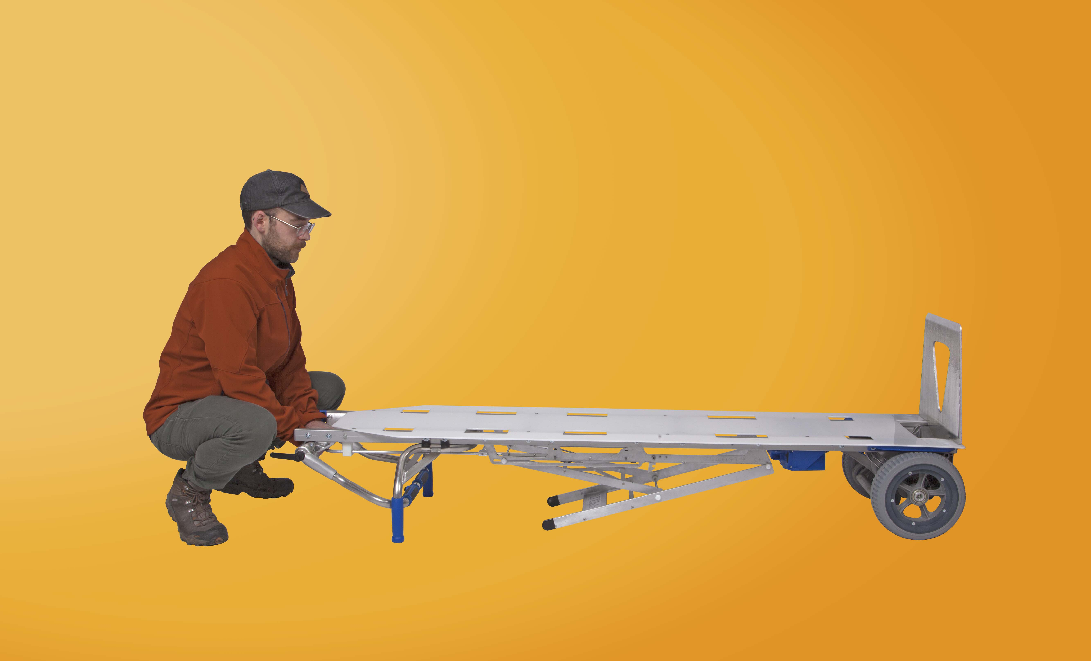

Specifications:

- Lightweight at only 55 lbs.

- Ergonomically designed to take strain off the back
- 375 lbs. maximum load capacity
- 19” x 72” inches in dimension
- Accommodates up to 6’ shoulder height
- Body glide board slots are placed to be compatible with body pouch and strap set. (fig. A)
- Multiple strap holes are usable in any stage of decomposing remains
- User friendly controls for quick change between ascending and descending stairs (fig. B)
- Two ascent buttons – one located on each set of handles. (fig. D)
- Rechargeable battery with charger (optional: second battery, car charge adaptor)
- Easy vehicle loading with QuickStand – two different levers to implement QuickStand™ (fig. C)
- Top handle has adjustable swivel movements while bottom set remains stationary. (fig. D)

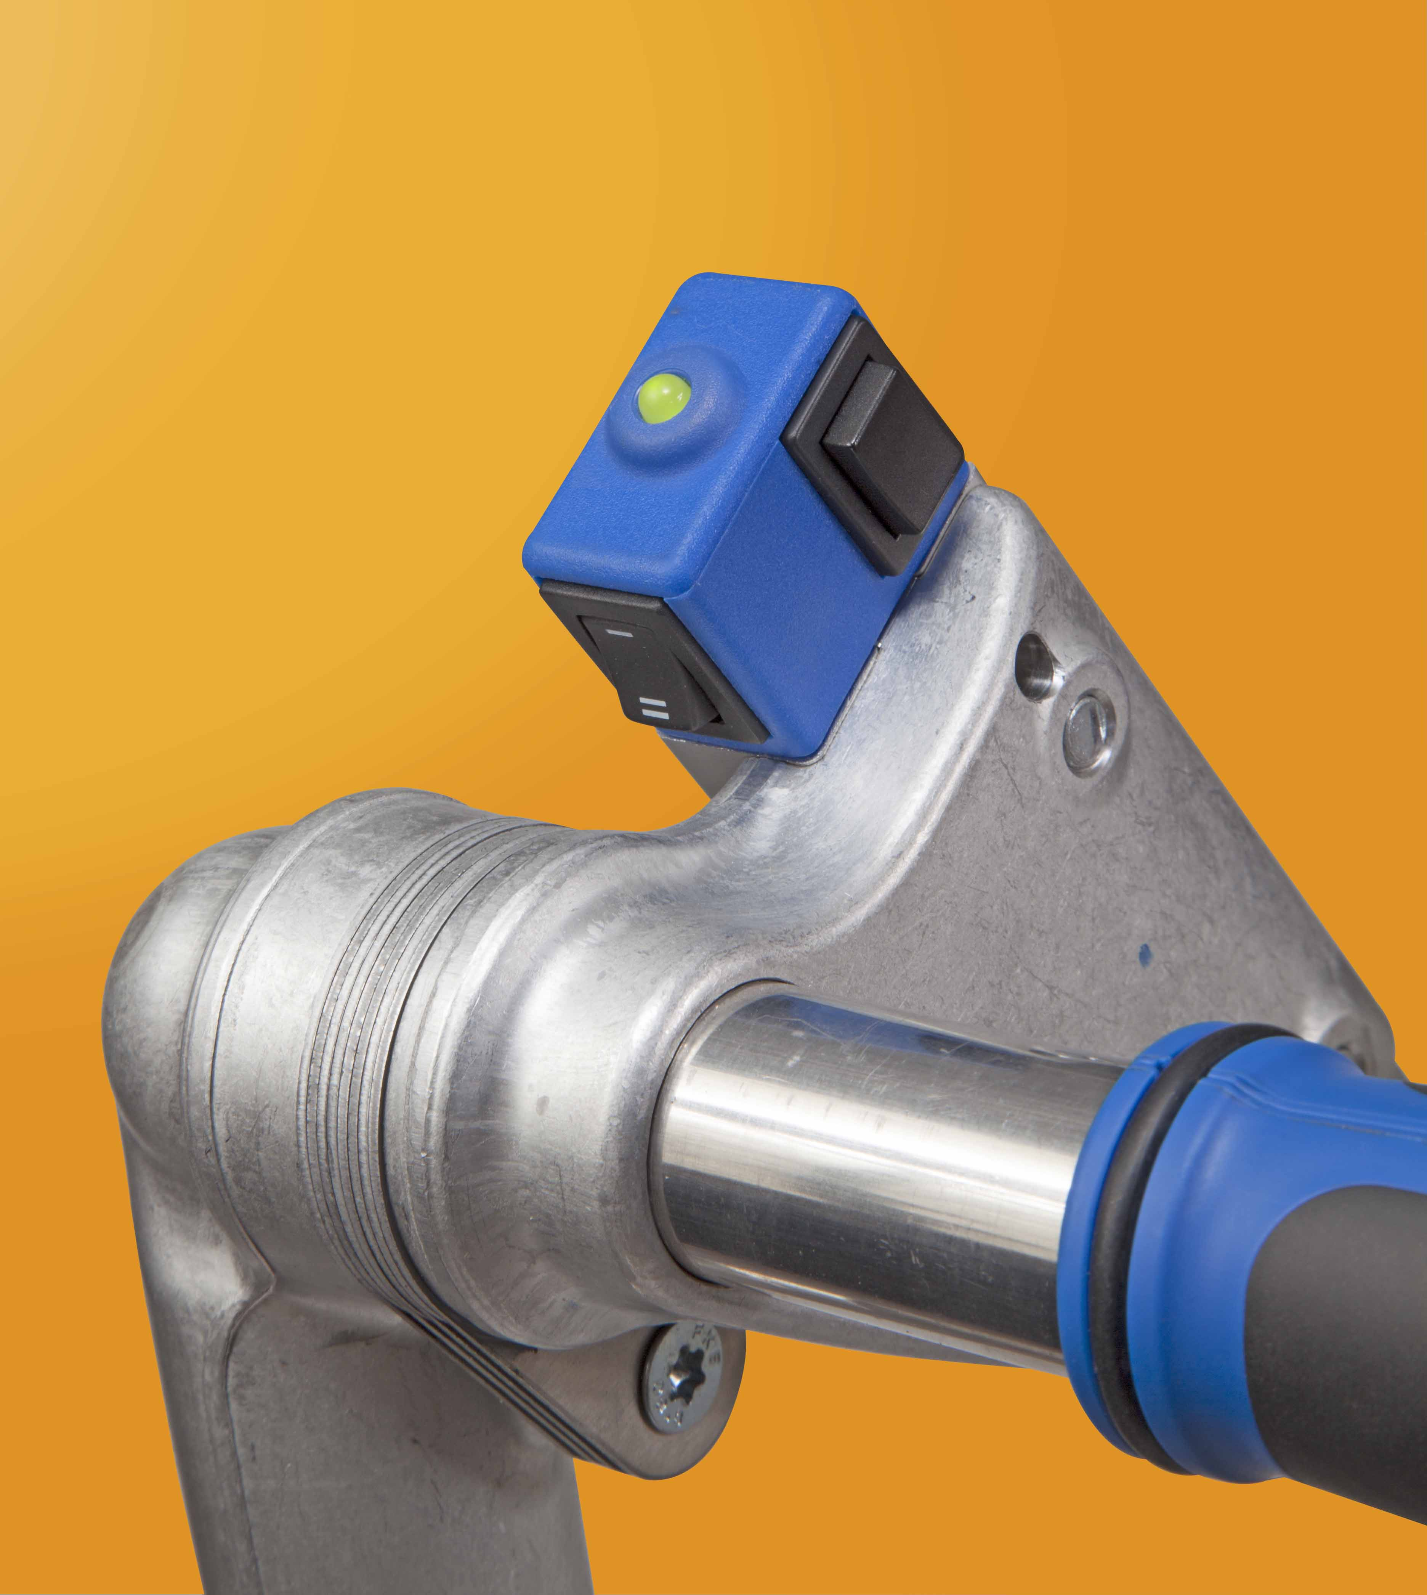
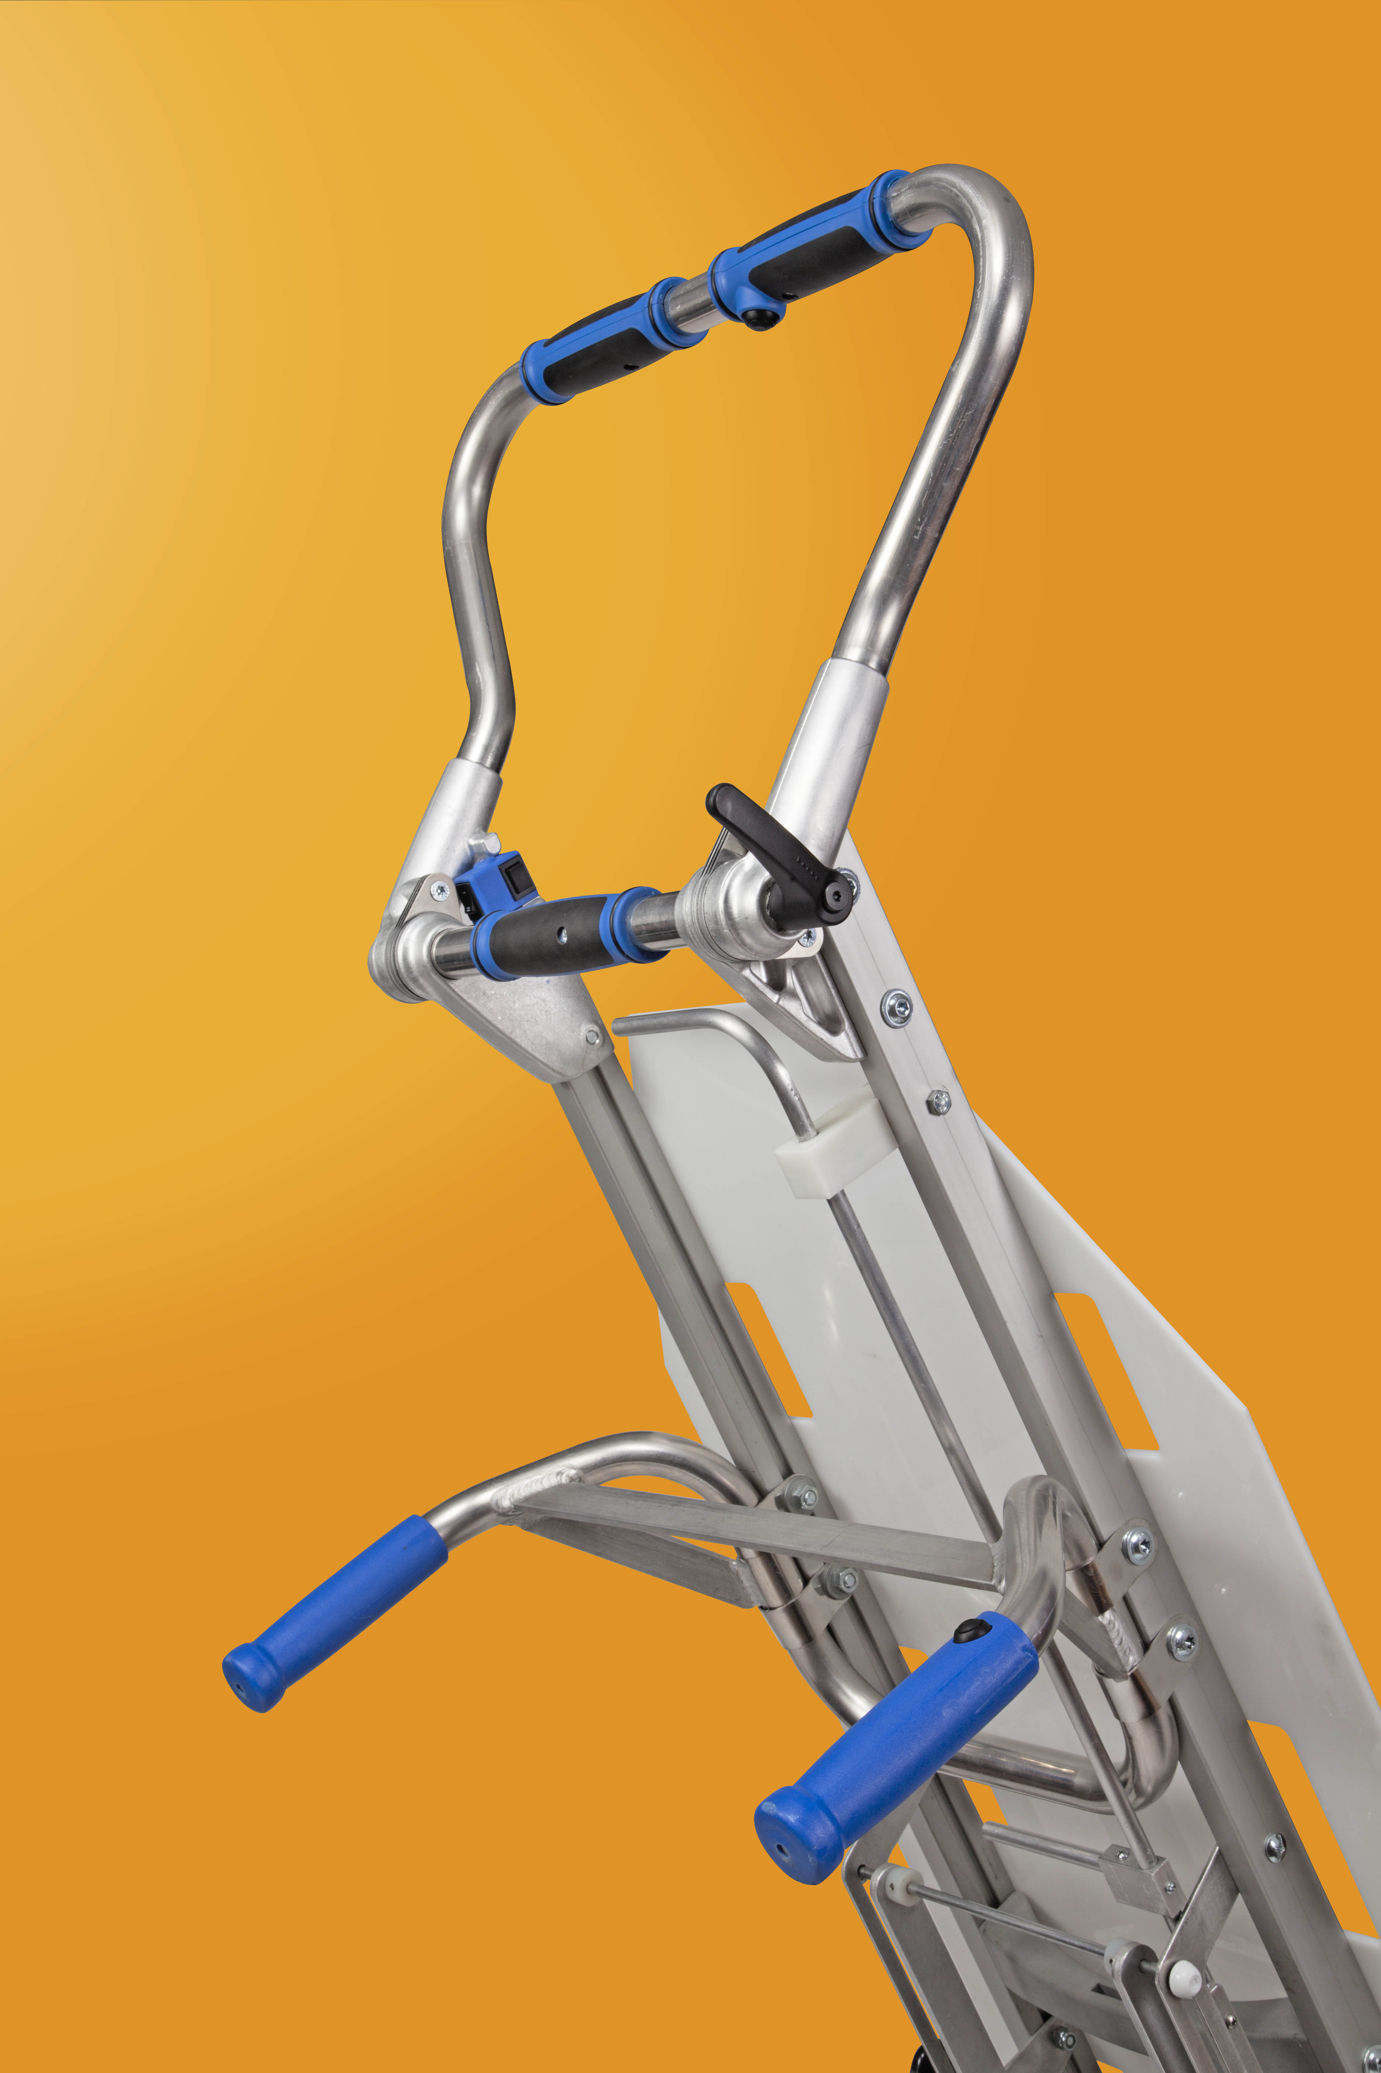
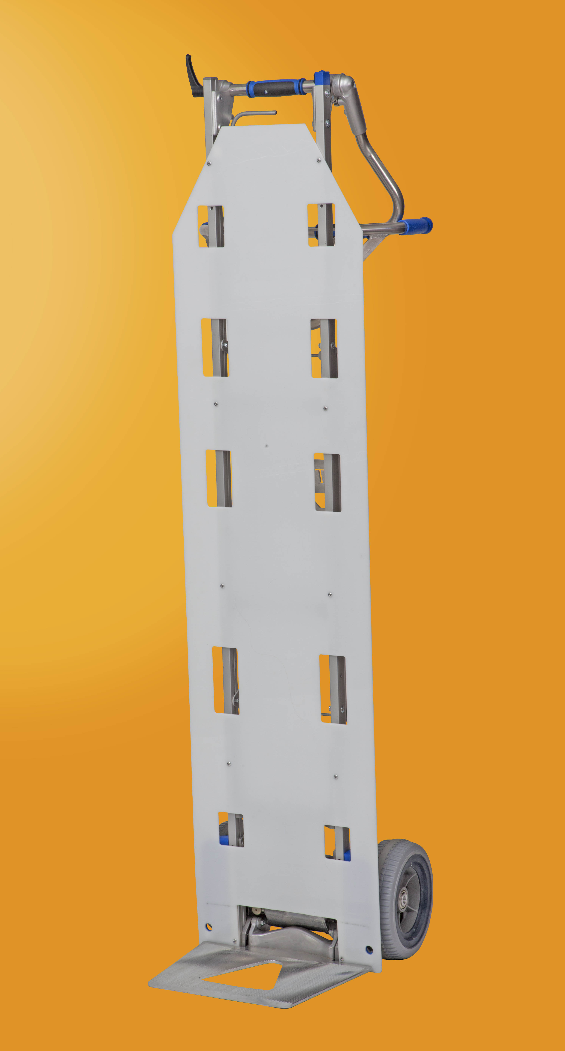
C
B
D
A

